ADVISORY FOR EXISTING CENTRAL EXCISE AND SERVICE TAX TAXPAYER FOR ACCESSING THE NEW CBIC-GST TAX PAYER PORTAL
(CBIC-ACES-GST INTEGRATED APPLICATION)
Attention is drawn to the existing ACES Portal namely www.aces.gov.in, the tax payer portal for online functionalities under Central Excise and Service Tax. The functionalities of ACES have been migrated and integrated with CBIC-GST Application now and available for tax payers under the CBIC-GST portal namely www.cbic-gst.gov.in with effective from 26th May 2019 vide Central Excise Notification No.01/2019-CE(NT) dated 08.05.2019 read with Board’s Circular No. 1069/2/2019/2019-CX dated 08.05.2019 issued in this regard.
The procedure for existing tax payers to login and register under Central Excise is explained as follows:
- The integrated CBIC Tax Payer portal for Central Excise, Service Tax and GST purpose is www.cbic-gst.gov.in

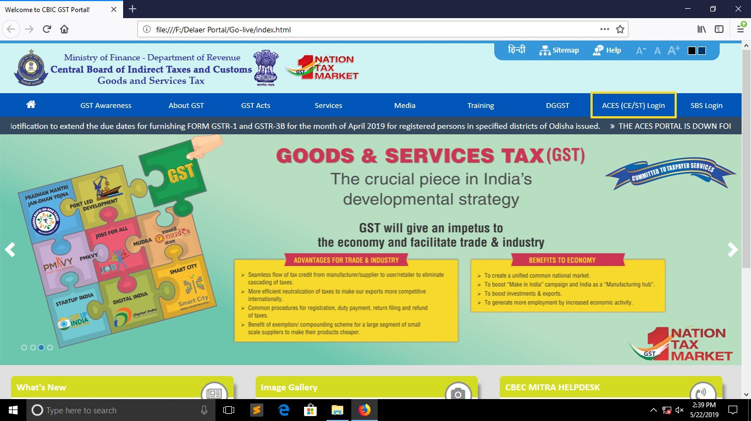

- The existing tax payer applicant will access the CBEC-GST tax payer portal namely the URL https://cbic-gst.gov.in and click on the link for “ACES( CE&ST)” on the Horizontal Menu Bar on the Top. The link leads to the ACES(CE &ST) Taxpayer login page.

- In the “Taxpayer Login”, the applicant need to provide existing user id and password credentials (used by them to login to ACES portal) as illustrated below:
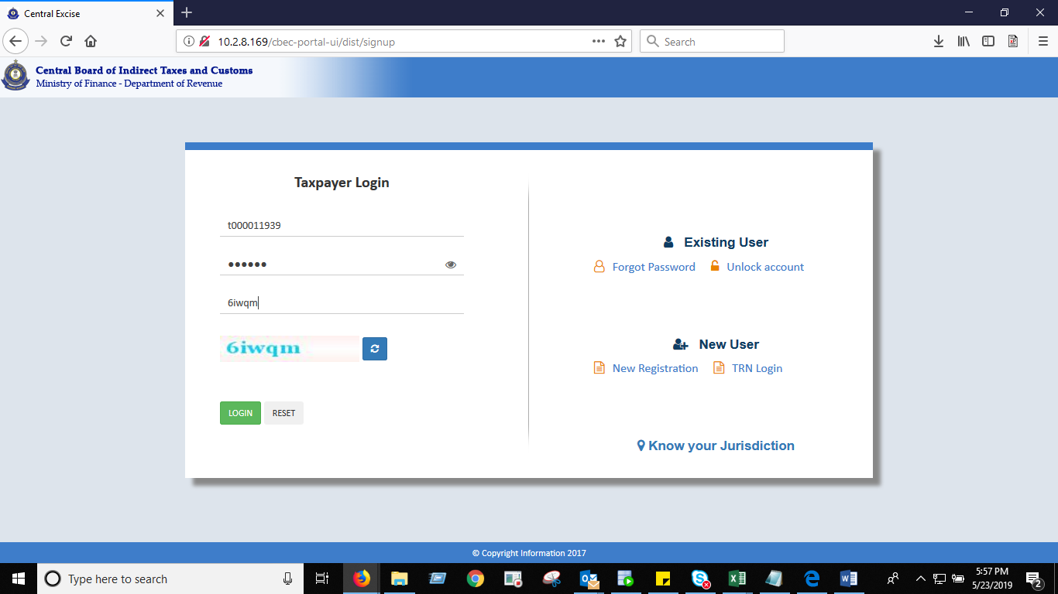

- On successful authentication, the user will be mandated to change the password.

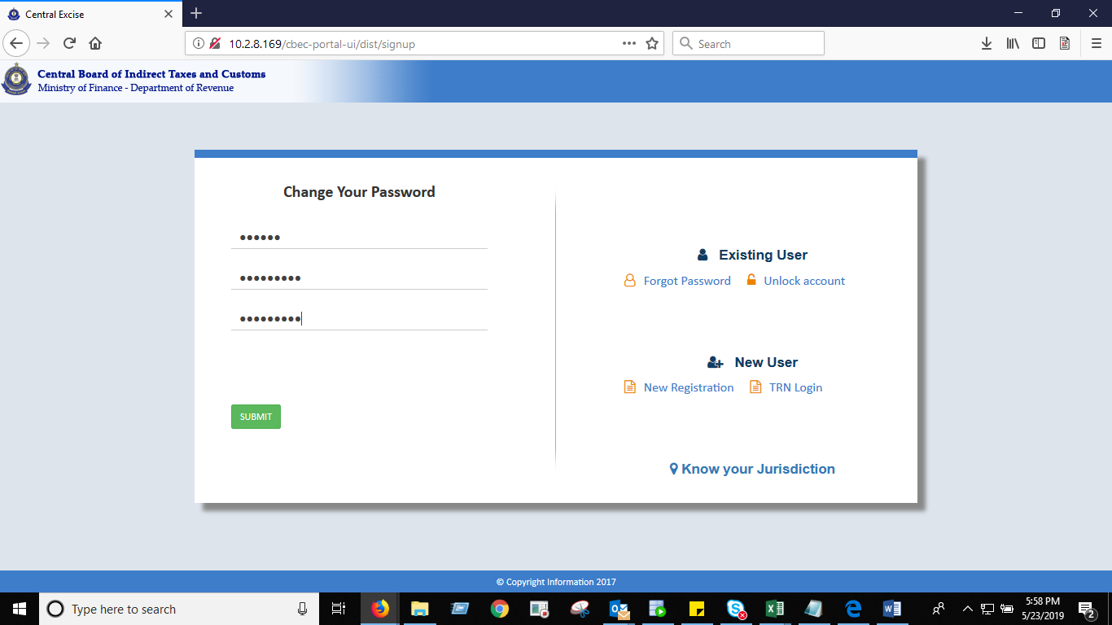

- Thereafter, the taxpayers can login to the CBIC GST integrated portal i.e, www.cbic-gst.gov.in with user id and the new password to do the transactions, like Amendments to Registration, filing of returns, filing of refund claims etc. as carried out earlier in the ACES portal(www.aces.gov.in).

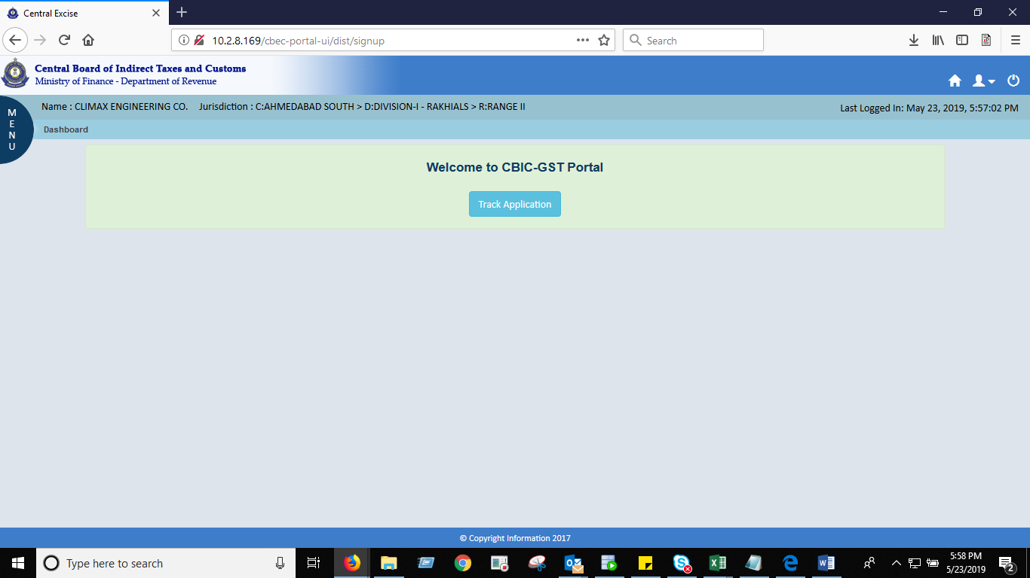

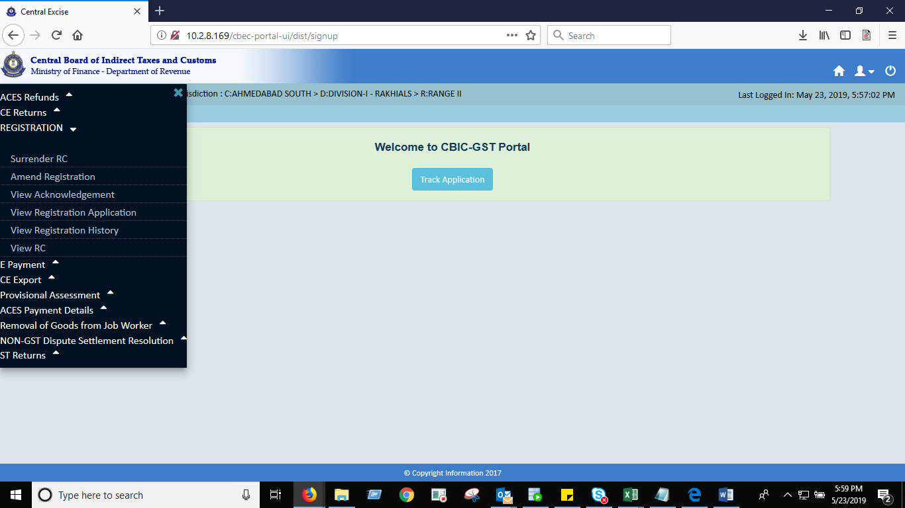
- If the Taxpayer is facing any issue while accessing the CBIC GST portal or changing the Password, the Taxpayer can contact the cbecmitra helpdesk either through calling the toll free number-18001200232 or through mail-cbecmitra.helpdesk@icegate.gov.in for resolution.

